The stat function I used in my visualization took the yearly means generated for q1.csv and took the maximum of the absolute values of the year to year differences. The formula in Excel for the 2nd row in cell AA2 would be: =max(abs(b2-c2),abs(c2-d2),abs(d2-e2),…,abs(y2-z2)). This gives me the largest price jump from year to year for products.

I chose to use a consistent scaling for all of the years to give a better sense of the overall growth of mean pricing from 2000 to 2024. Changing the scaling to show the minimum and maximum value per year would give a better sense of the relative pricing per year, but would lose the sense of growth over the time scale.

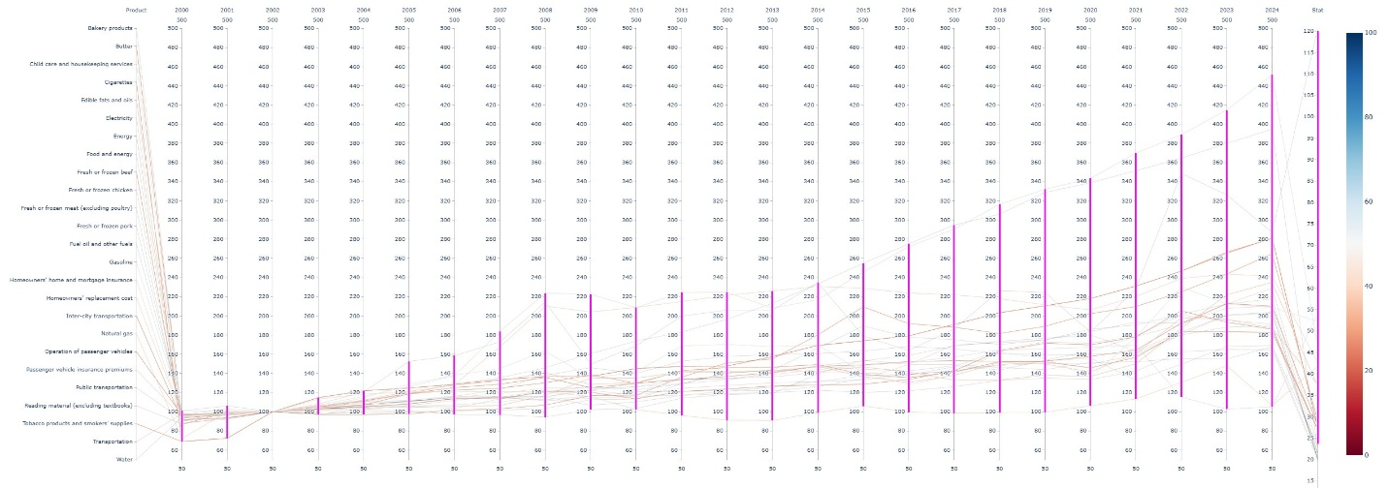

The plot produced shows the 25 products with the largest price change in any single year span.

Oddly I see a convergence point in 2002, which would suggest to me that there might not be valid data for that year for the products being examined and should be scrutinized more deeply based on the static scaling from year to year.

There are some products showing slow growth and a few that are close to doubling over the last 10 years, which surprisingly don’t correspond to the highest year-to-year differences.